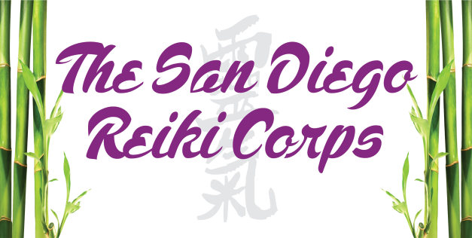
Membership Renewal/Update Form Renewal ____
Personal Information Update ____
Last Name |  | First Name |  |  |  | Middle Initial
Email |  | Home Number |  | Cell Number
Address
City |  | State |  |  | Zip Code
Reiki Level (additional levels since original application) |  |  | From whom did you learn? (Include teacher’s name, email address and telephone number)
Occupation, Other Healing Arts, Training, Certificates:

Website Information
(If you want your information on the San Diego Reiki Corps website please complete the information below)
Please note the information provided needs to be relevant to Reiki)
Name

Style of Reiki (eg. Usui or Karuna or Jikiden etc)

Title (eg. Reiki Practitioner or Reiki Master Practitioner or Reiki Master Teacher and Practitioner)

Email

Credentialed Organization (eg CEU Provider" BRN # xxxxxx)

Website (Max of two – One for business and one for Meetup)

Signed: _____________________________________________ Date: ______________________

Print Name: ________________________________________________________

To update contact information return this form via e-mail or mail to the SDRC office. If Reiki status has changed, also send a copy of new Reiki Certificate.

To renew membership return this form via e-mail and pay renewal online to:
Membership@SanDiegoReikiCorps.org
OR
Mail $25.00 check payable to SDRC with renewal form to:
SDRC, 3231-C Business Park Drive, #213, Vista, A 92081

